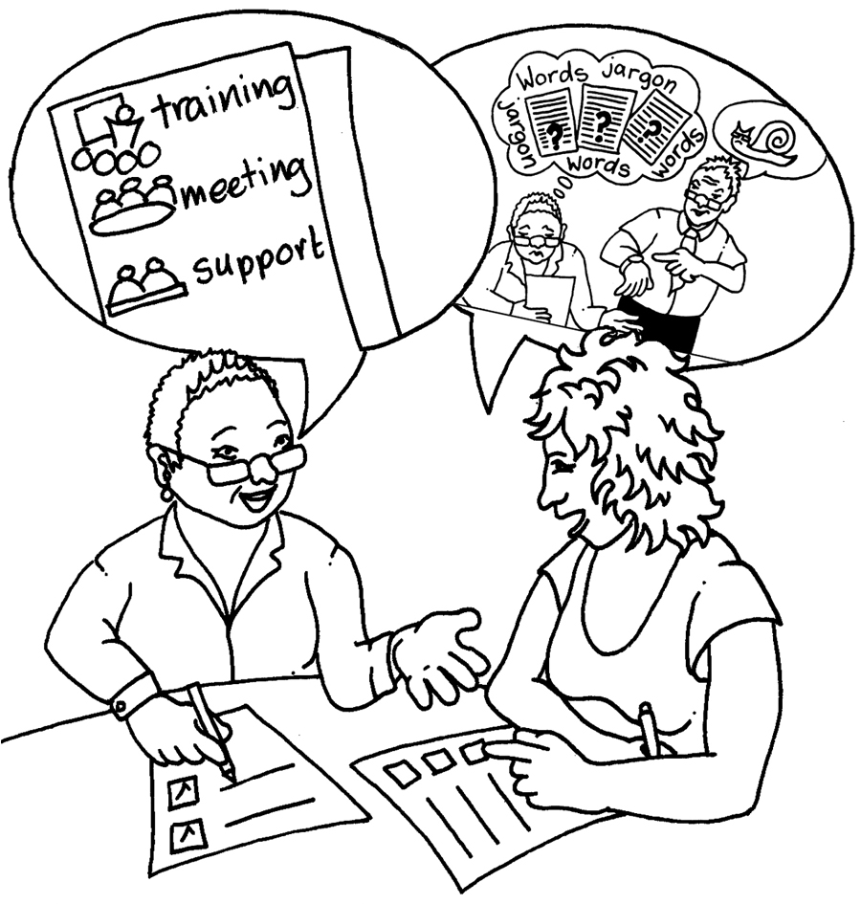

# Supervision notes:

Area of work: \_\_\_\_\_\_\_\_\_\_\_\_\_\_\_\_\_\_\_\_\_\_\_\_\_\_\_

Date we met: \_\_\_\_\_\_\_\_\_\_\_\_\_\_\_\_\_\_\_\_\_\_\_\_\_\_\_

|  |  |
| --- | --- |
| **Persons name:** |  |
| How we are feeling about work:  ::EMPLOYMNET IMAGES final edit:Problems at work:thinking_bad.jpg::EMPLOYMNET IMAGES final edit:Accessible working:thinking_good.jpg |  |
| What have you been doing:  ::EMPLOYMNET IMAGES final edit:Accessible working:workplan_follow.jpg |  |
| What you plan to do next:  **E:\General Picture Bank Elements\Pics\Action Plan.jpg** |  |

|  |  |  |  |
| --- | --- | --- | --- |
| **Toil – Extra Hours**  :Employers Guidance:EMPLOYMNET IMAGES final edit:Time and planning:hours_16.jpg | When you plan to take time back | | |
| **Annual leave**  :Employers Guidance:EMPLOYMNET IMAGES final edit:Time and planning:leave_holiday_date.jpg | Days left/to be booked | | |
| **Training**  :Employers Guidance:EMPLOYMNET IMAGES final edit:Training and development:staff_skilled.jpg |  | | |
| **Workload**  :Employers Guidance:EMPLOYMNET IMAGES final edit:Time and planning:have_I_got_time.jpg |  | | |
| **Budget**  :Employers Guidance:EMPLOYMNET IMAGES final edit:Money and budgets:budgeting.jpg |  | | |
| **Any other things:**  ::EMPLOYMNET IMAGES final edit:idea_bulb.jpg |  | | |
| Action Plan: | | | |
| Things that need to be done | **Do by?** | | Done |
|  |  | | ❑ |
|  |  | | ❑ |
|  |  | | ❑ |
|  |  | | ❑ |
|  |  | | ❑ |
|  |  | | ❑ |
|  |  | | ❑ |
|  |  | | ❑ |
|  |  | | ❑ |
|  |  | | ❑ |
| **Signed by:** | |  | |
| **Supervised by:** | |  | |
| **Next Supervision:** | |  | |